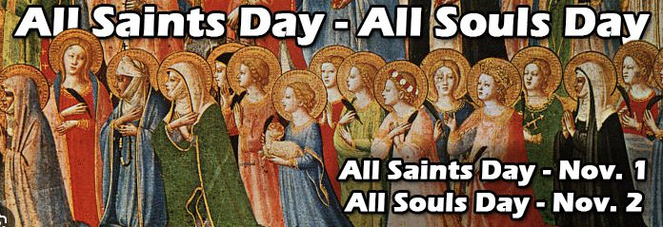
November Lector Schedule
November 1/2nd All Saints Day & Commemoration of All the Faithful Departed
4:00 pm Tina Dibble
7:30 am Matt Ryan
9:30 am Joseph Savidge
11:00 am Nicole Russo

November 8/9th The Dedication of the Lateran Basilica

4:00 pm Mark Murnane
7:30 am Bill Thramann
9:30 pm Kristen Bittar
11:00 pm Bob Fish

November 15/16th Thirty-Third Sunday in Ordinary Time

4:00 pm Eileen Delprete
7:30 am Fran Kiernan
9:30 am Paige Fitch
11:00 am Eva Kaminski

November 22/23th Our Lord Jesus Christ, King of the Universe
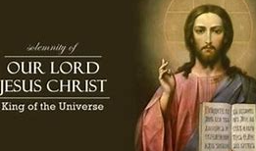
4:00 pm Chris Healy
7:30 am John Lenihan
9:30 am Eileen DiMauro
11:00 am Janet Fischer

November 29/30th The First Sunday of Advent


4:00 pm Fran Kiernan
7:30 am Bob Fish
9:30 am Tina Dibble
11:00 am Nicole Russo

